**What do investment bankers actually do?**

I can't put it better than the senior banker who once asked me why I had chosen to "become a traveling money salesman." I've dined out on [that phrase](http://thebillfold.com/2012/07/how-dealbreakers-matt-levine-does-money/)ever since, and probably owe him royalties, though I'm not going to sweat it since he's quite rich.

Investment bankers are traveling salesmen (and women), which explains why many of them are so ornery so much of the time. It also explains why, while in popular perception investment bankers are arrogant jerks wearing Hermès ties, actual individual bankers tend to be perceived by their clients as obsequious and needy. Because they're selling something. Specifically, they're selling money to companies.

Say a company wants to get money to build a factory or hire more workers or whatever. It can get that money by issuing stock or bonds. "Issuing bonds" just means "borrowing money from strangers." "Issuing stock" is more existentially complicated, but "giving people partial ownership of your company in exchange for cash" is good enough.

Issuing stocks or bonds requires finding someone to buy them, and most companies aren't good at selling stocks and bonds, so they hire investment bankers as middlemen to help them find people looking to invest money.

(Incidentally, "investment bankers," as the term is used in the industry, work at investment banks that employ trading and sales staffs, who make trades and sell stocks and bonds to investors. These people are not normally called "investment bankers." In fact, the large majority of people at investment banks are not "investment bankers." Confusing, I know.)

When a company decides to issue stock or bonds, investment bankers perform "due diligence" to make sure the company's accountants will say that the company's financial statements say what they say they say. Then they write up a prospectus explaining the risks and benefits of buying the stock or the bond.

Finally, investment bankers hand the prospectus to the sales and trading staffs at their bank, who go out and convince mutual funds, hedge funds, rich people, and moderately less rich people to buy the stocks and bonds, while the investment bankers stand around saying helpful things like "good luck!" and "try to sell more stock!" and "hurry!"

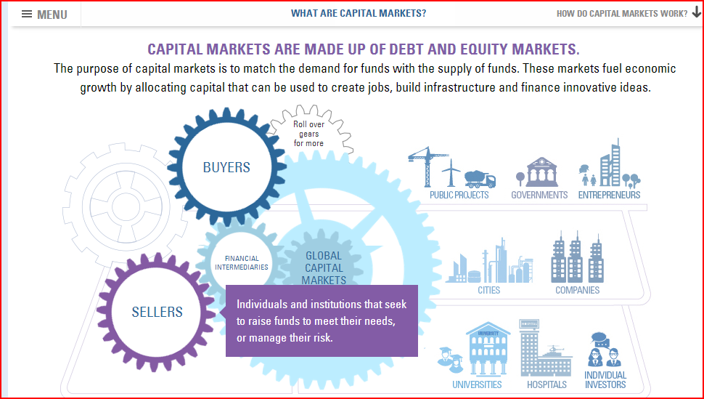

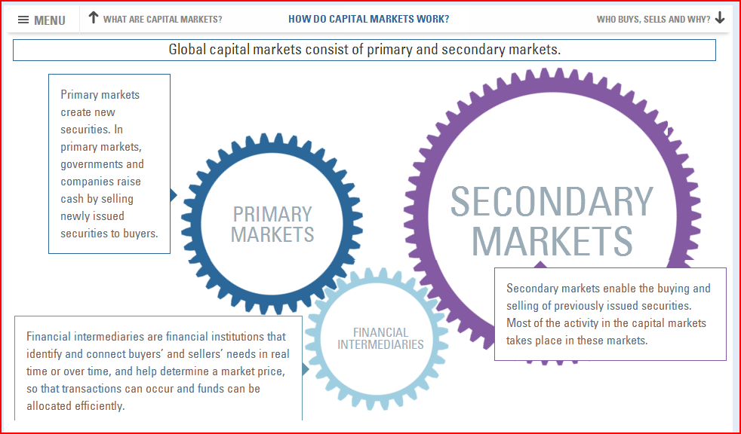

**What is Investment Banking?**

**So what does an investment bank actually do?**Several things, actually. Below we break down each of the major functions of the investment bank, and provide a brief review of the changes that have shaped the investment banking industry through the aftermath of the 2008 financial crisis. Click on each section to learn more.

*The JP Morgan building*

* [Raising Capital & Security Underwriting](http://www.wallstreetprep.com/knowledge/raising-capital-and-security-underwriting/). Banks are middlemen between a company that wants to issue new securities and the buying public.
* [Mergers & Acquisitions](http://www.wallstreetprep.com/knowledge/ma-advisory-and-other-corporate-reorganizations/). Banks advise buyers and sellers on business valuation, negotiation, pricing and structuring of transactions, as well as  procedure and implementation.
* [Sales & Trading and Equity Research](http://www.wallstreetprep.com/knowledge/sales-trading-and-equity-research/). Banks match up buyers and sellers as well as buy and sell securities out of their own account to facilitate the trading of securities
* [Retail and Commercial Banking](http://www.wallstreetprep.com/knowledge/retail-brokerage-and-commercial-banking/). After the repeal of Glass-Steagall in 1999, investment banks now offer traditionally off-limits services like commercial banking.
* [Front office vs back office](http://www.wallstreetprep.com/knowledge/investment-bank-organizational-structure/). While the sexier functions like M&A advisory are “front office,” other functions like risk management, financial control, corporate treasury, corporate strategy, compliance, operations and technology are critical back office functions.
* [History of the industry](http://www.wallstreetprep.com/knowledge/the-history-of-investment-banking/). The industry has changed dramatically since John Pierpont Morgan had to personally bail out the United States from the Panic of 1907. We survey the important evolution in this section.
* [After the 2008 financial crisis](http://www.wallstreetprep.com/knowledge/investment-banking-after-the-2008-financial-crisis/). The  industry has not fully recovered from the financial crisis that gripped the world in 2008. How has the industry changed and where is it going?

**Related topics**

The **capital market risk** usually defines the risk involved in the investments. The stark potential of experiencing losses following a fluctuation in security prices is the reason behind the capital market risk. The capital market risk cannot be diversified.   
The capital market risk can also be referred to as the capital market systematic risk. While an individual is investing on a security, the risk and return cannot be separated. The risk is the integrated part of the investment. The higher the potential of return, the higher is the risk associated with it.   
  
The examination of the involved in the capital market investment is the one of the prime aspects of investing. It can be easily said that the risk distinguishes an investment from the savings. The systematic risk is also common to the entire class of liabilities or assets.   
Depending on the economic changes the value of investments can fall enormously. There may be some other financial events also impacting the investment markets. In order to give a check to the capital market risk, the asset allocation can be fruitful in some cases.   
Any investment in stocks or bonds comes with the following types of risks. 

* Market Risk
* Industry Risk
* Regulatory Risk
* Business Risk

The market risk defines the overall risk involved in the capital market investments. The stock market rises and falls depending on a number of issues. The collective view of the investors to invest in a particular stock or bond plays a significant role in the stock market rise and fall. Even if the company is going through a bad phase, the stock price may go up due to a rising stock market. While conversely, the stock price may fall because the market is not steady even if the investor's company is doing well. Hence, these are the market risks that the stocks investors generally face.   
  
The industry risk affects all the companies of a certain industry. Hence the stocks within an industry fall under the industry risk. The regulatory risk may affect the investors if the investor's company comes under the obligation of government implemented new regulations and laws. The business risk may affect the investors if the company goes through some convulsion depending on management, strategies, market share and labor force.

**Enterprise Risk**

Enterprise risk management (ERM) is a framework to reduce earnings volatility through a robust risk governance structure and strong risk culture, supported by sound risk management capabilities. It is the organization’s enterprise risk competence—the ability to understand, control, and articulate the nature and level of risks taken in pursuit of business strategies—coupled with accountability for risks taken and activities engaged in, which contributes to increased confidence shown by stakeholders.

[More on Enterprise Risk at RMA](http://www.rmahq.org/risk-management/enterprise-risk).

**Credit Risk**

In the past, managing the credit portfolio was considered good risk management. But in today's broader, more complex environment, best-practice institutions understand that they need to measure and manage risk across the entire enterprise. We recognize that managing credit risk is essential to enterprise-wide risk management, so we offer products and services to institutions and individuals involved in retail, commercial, and corporate credit risk. RMA is the premier provider of commercial credit education and information.

- See more at: http://www.rmahq.org/risk-management#sthash.MRijmflF.dpuf

<http://riskencyclopedia.com/articles/value-at-risk/>

**Value-at-risk** (VaR) is a probabilistic metric of market risk (PMMR) used by banks and other organizations to monitor risk in their trading portfolios. For a given probability and a given time horizon, value-at-risk indicates an amount of money such that there is *that* probability of the portfolio not losing more than *that* amount of money over *that* horizon. For example, if a portfolio has a one-day 90% value-at-risk of USD 3.2 million, such a portfolio would be expected to not lose more than USD 3.2 million, nine days out of ten.

Different choices for the probability and time horizon correspond to different **value-at-risk metrics**. Actually, a value-at-risk metric is specified with three items:a time horizon—one trading day in our example;

* a probability—90% in our example; currency—USD in our example.
* • a time horizon—one trading day in our example;
* • a probability—90% in our example;
* • a currency—USD in our example.
* **Derivative instruments** (or simply **derivatives**) are a category of financial **instruments** that includes options, futures, forwards and swaps.

RBC developer

JOB SPECIFICATIONS

Technical

Hands-on experience with Java. Familiarity with other languages desirable

Detailed knowledge of software design principals, including algorithms, data structures, design patterns

Experience with software development process and tools like SVN, continuous integration

Experience with relational databases, data modeling, and data modeling tools

Business analysis and project management skills

Business

Excellent customer service focus with Risk business

Significant experience with market, credit, and/or liquidity risk management.

Thorough understanding of risk metrics such as VAR and stress

Experience with regulatory reporting and Enterprise Risk reporting

Experience with Business Analysis, workflow, functional specifications

Strong understanding of financial instruments, including derivatives, equities, rates

Experience with front-to-back data flows and market data

What is **SVN**

**Apache Subversion** (often abbreviated **SVN**, after the command name *svn*) is a [software versioning](http://en.wikipedia.org/wiki/Software_versioning) and [revision control](http://en.wikipedia.org/wiki/Revision_control) system distributed as [free software](http://en.wikipedia.org/wiki/Free_software) under the [Apache License](http://en.wikipedia.org/wiki/Apache_License).[[1]](http://en.wikipedia.org/wiki/Apache_Subversion#cite_note-1) Developers use Subversion to maintain current and historical versions of files such as [source code](http://en.wikipedia.org/wiki/Source_code), web pages, and documentation. Its goal is to be a mostly compatible successor to the widely used[Concurrent Versions System](http://en.wikipedia.org/wiki/Concurrent_Versions_System) (CVS).

Its a complex subject but basically **SVN, git, CVS, clearcase,** etc are all version control system that solve these problems. Here are some wiki articles to read.

Data modeling

**Data modeling** in [software engineering](http://en.wikipedia.org/wiki/Software_engineering) is the process of creating a [data model](http://en.wikipedia.org/wiki/Data_model) for an [information system](http://en.wikipedia.org/wiki/Information_system) by applying formal data modeling techniques.

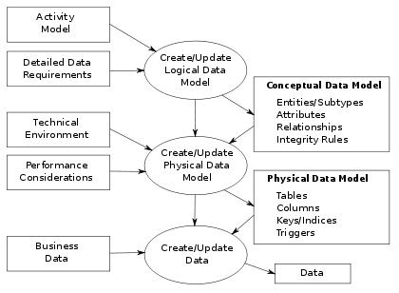

Questions:

* 1. I think you are using SVN, do you use any GUI client or configuration is through client such Assembla, AnkhSVN? Because I use MKS Integrity Client?
  2. The job description reads as migration of risk systems? May I know in which technology the existing applications were written in.
  3. What is the database you are using existing and new?
  4. If it is application migration, are you planning to re design the database model?
  5. What are the major factors RBC considers for calculating the Market Risk
  6. What is the source for analyzing the market risk

ds